How to Enter Oder
Step 1: Go to your order entry search ED Restrictive Intervention. You will select either Violent or Non-Violent depending on the situation and type of restraint used.
***This needs to be placed within an hour of the patient being in restraints. Verbal orders are NOT allowed. Restraint orders must be placed by Provider ONLY ***
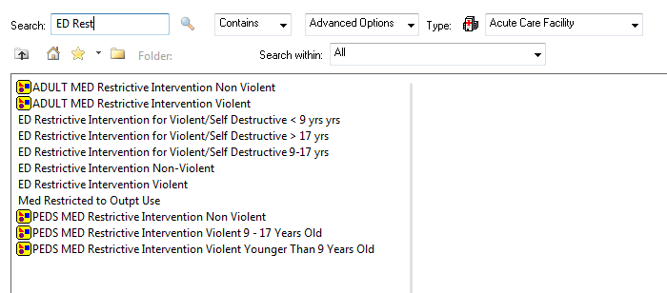
Ensure you have selected appropriate violent vs non-violent order. If violent ensure you select the appropriate age group.

**You can add any of these orders to your favorites by right clicking on the order and selecting “Add to Favorites”. This will ensure it is easier to search in the future.

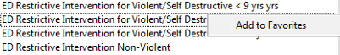

Step 2: You will be required to ensure all fields for order are selected and completed.
- Know the type of restraint being used and ensure the correct order is selected.
  - Violent Restraints are the Heavy-Duty wrist and/or ankle.
***Mercy and South Park DO NOT carry locking restraints. ***
  - Non-Violent Restraints include soft wrist and/or ankle, mittens, posy, etc.
*** You cannot order Heavy Duty restraints for Non-Violent orders!!***
- If placing in both wrist and ankle, ensure both are included in the order.
- Orders also need to include Criteria for placement and reason for release.
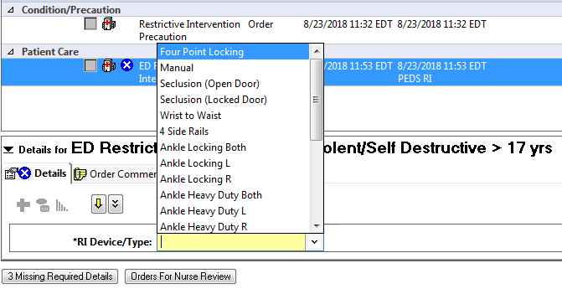
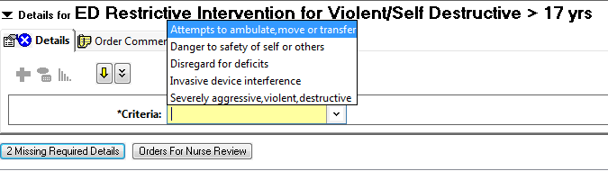

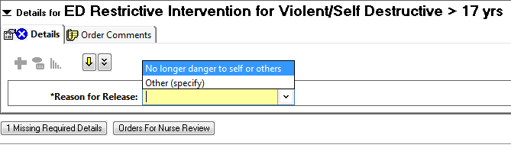

Once the order is entered you are required to complete a Face to Face evaluation.
*This needs to be documented by Provider only within an hour of the patient being in restraints. None of the nursing staff are qualified and receive yearly competency to complete. *
- The Face to face documentation is an AdHoc form.
  - Locate this form by selecting AdHoc from the top tool bar of the home tracking board
‘

Step 3: Select ED Face to Face Evaluation.

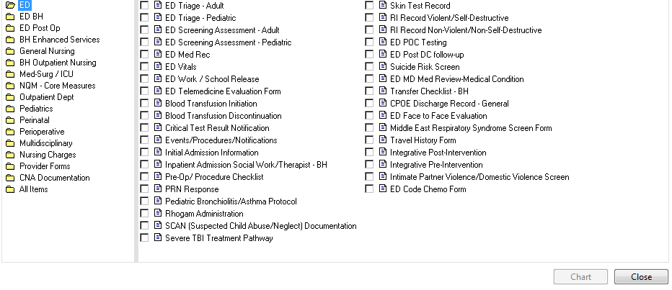
Step 4: Ensure all fields are completed in this form.
- Immediate Situation: Select “Restraints”.
- Patient Demonstrated Behavior: Select all appropriate fields.
- Patient’s Reaction to the Intervention: Select all appropriate fields
- Physical Examination: Select “Orders entered” and the appropriate assessment depending on the patient’s physical condition and if any injury has resulted in placing the patient in restraints.
- Patient’s Physical Condition: Majority should be “Stable”. However, if there are negative results due to the restraints please documented what they are and address by discontinuing the restraints and changing the plan of care.
- Assessment Decision: Select “Continue with RI”. With the except for when you selected that there were negative affects to the patient’s physical condition in this instance select “Discontinue RI”.
- RI Plan of Care: Select “No change in plan of care”. With the except for when you selected that there were negative affects to the patient’s physical condition if that is the case select “Change plan of care”.
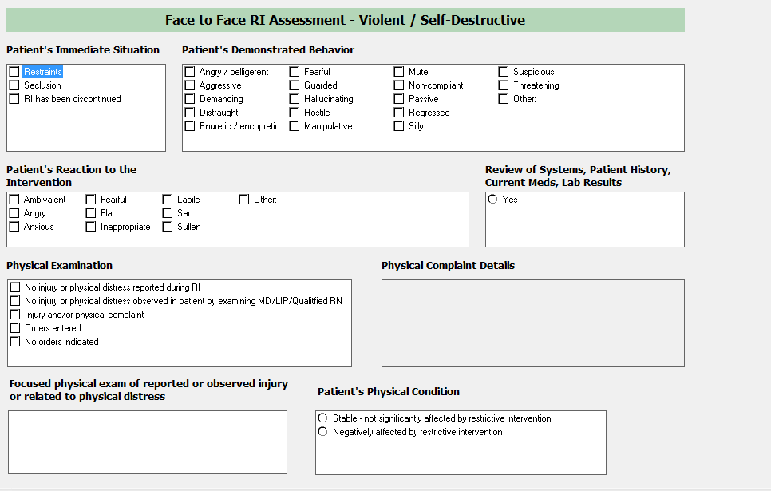
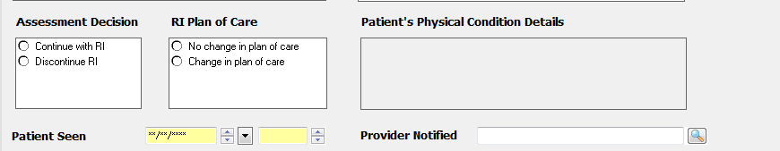

Step 5: Save the Face to Face Evaluation by clicking the green check mark in the top left corner and close.
